Web/Mobile App Based Resources
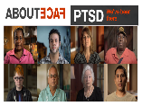 | AboutFace, Veterans, family members and clinicians share their experiences with PTSD and PTSD treatment in moving film clips. Learn what you can do to help yourself or a loved one, from the stories of people who have been there.
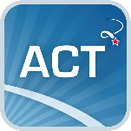 | ACT Coach offers tools for Veterans who are in Acceptance and Commitment Therapy learning to deal with unpleasant experiences.
 | AIMS offers education about anger and opportunities for finding support. It creates an anger management plan and has tools to manage reactions.
 | Annie provides automated text messages to promote self-care for Veterans enrolled in VA health care. It can also send Veterans messages from their local VA medical facility.
 | Breathe2Relax Provides instruction on diaphragmatic “belly” breathing, which helps lower stress and reduce anxiety. Graphics, animation, narration, and videos lead users through several breathing exercises.
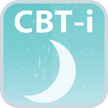 | CBT-i Coach is for people who are engaged in Cognitive Behavioral Therapy for Insomnia. It helps Veterans develop positive sleep routines and improve sleep environments.
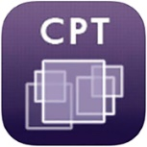 | CPT Coach contains support materials for Cognitive Processing Therapy to help Veterans manage post-traumatic stress disorder.
CRAFT-PTSD Course
Community Reinforcement and Family Training (CRAFT) - Posttraumatic Stress Disorder (PTSD) is a web-based course for family members of Veterans working to manage PTSD.
CRAFT-SUD Course
Community Reinforcement and Family Training (CRAFT) -Substance Use Disorder (SUD) is a web-based course for family members of Veterans working to manage SUD.
Dream EZ
Helps the user rewrite nightmares into less disturbing dreams for a better night’s sleep, using the principles of imagery rehearsal therapy (IRT).
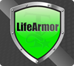 | LifeArmor  Has information on 17 common health concerns, including sleep, depression, relationship issues, and post-traumatic stress. Includes self-assessments to help measure and track symptoms.
 | Mindfulness Coach offers exercises, information, and a tracking log to help practice mindfulness.
 | Mindfulness Coach 2 provides a self-guided training program designed to help Veterans understand and adopt a simple mindfulness practice.
 | Mood Coach helps Veterans learn and practice Behavioral Activation through positive activities. It's designed to boost the Veterans mood.
 | MOVE! Coach allows Veterans to monitor, track, and receive feedback on progress with exercise, diet, and weight loss goals.
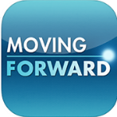 | Moving Forward teaches problem-solving skills to overcome obstacles and deal with stress. It's helpful for returning to civilian life, balancing family, and coping.
 | Objective Zero The Objective Zero App connects Veterans, Service members, their families, and caregivers to peer support via voice, video, and text message. Users also get free access to wellness resources, such as yoga and meditation sessions, and a catalogue of mental health resources.

Pain Coach App for Vet
Pain Coach offers helpful tools to track and manage pain.
Pain and Opioid Safety

Serves those coping with pain by providing information, resources, and an effective mechanism for tracking pain. The app contains information and FAQs for patients on the use of opioids in pain management, as well as tools and materials for providers using opioids in clinical practice.
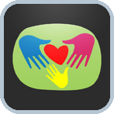 | Parenting2Go provides tools to strengthen parenting skills. It addresses the challenges that come with parenting and offers access to additional resources.
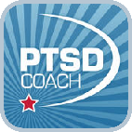 | PTSD Coach provides information about PTSD and a self-assessment. It has educational tools that help manage PTSD.

PE Coach 2
Supplement PE therapy for PTSD with a health professional.
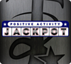 | Positive Activity Jackpot  Helps users who may be overwhelmed by depression find nearby enjoyable activities. Can't decide? Let the app’s jackpot function make the choice. See “Resources” for a clinician’s guide.
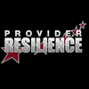 | Provider Resilience  Gives health care providers tools to manage burnout, compassion fatigue, and secondary traumatic stress, keeping them productive and emotionally healthy as they help others.

PTSD Family Coach
Support and tools for those living with someone who has PTSD.

Rx Refill

Request, refill and track VA prescriptions with ease.

STAIR Coach

Take the step, enhance STAIR in-person psychotherapy.
 | Stay Quit Coach creates a tailored quit plan to stop smoking. It provides tools to help with urges to smoke, and messages to help you stay smoke-free.
T2 Mood Tracker
Tracks a user’s range of emotions and behaviors to show how their life is affected by thoughts, moods, changes at home or at work, and events. Helps identify trends and triggers, and info can be shared with a health care provider.
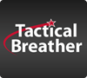 | Tactical Breather  Provides guided breathing instruction to gain control over heart rate, emotions, concentration, and other physiological and psychological responses during stressful situations.
 | VA Video Connect brings together Veterans with their health care team from anywhere. It allows quick and easy health care access from any mobile or web-based device.
 | VetChange provides tools for cutting down or quitting drinking. It has tools for managing stress and guidance to find professional treatment.
Virtual Hope Box
Contains simple tools to help users with coping, relaxation, distraction, and positive thinking using personalized audio, video, pictures, games, mindfulness exercises, activity planning, inspirational quotes, and coping statements.

